MOBI3002/1013: A1 – Hello

Name: Connor Goodwin
W#: W0488245
Date: 2025-09-08

CODE

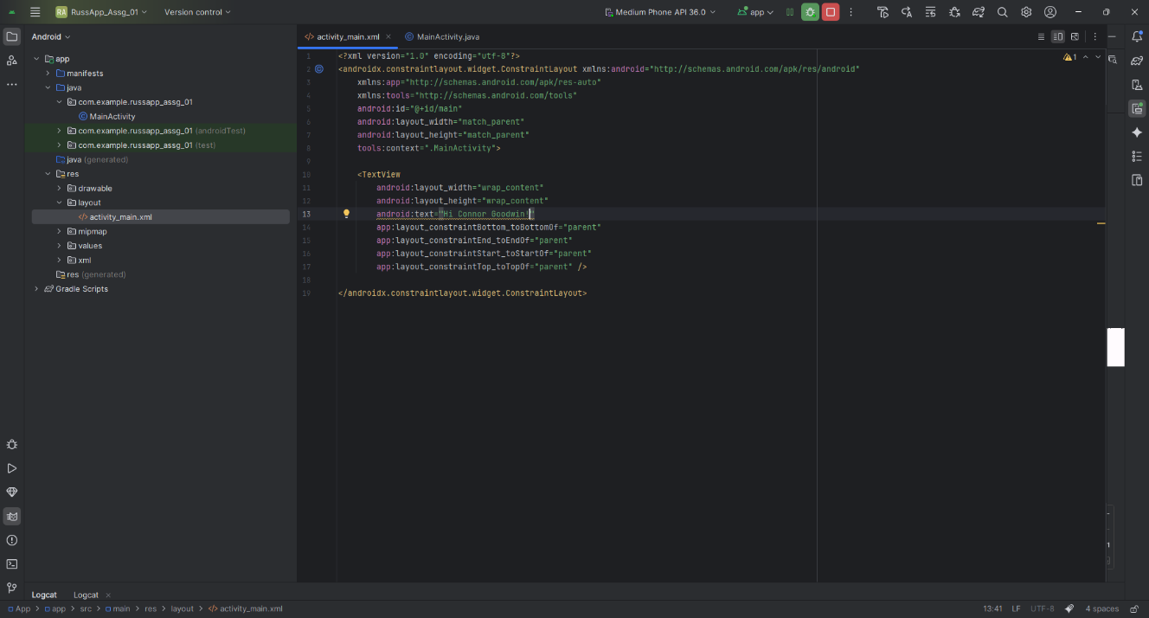
- CODE - Line 13: Code that shows “Hi Connor Goodwin!” On the android emulator screen.

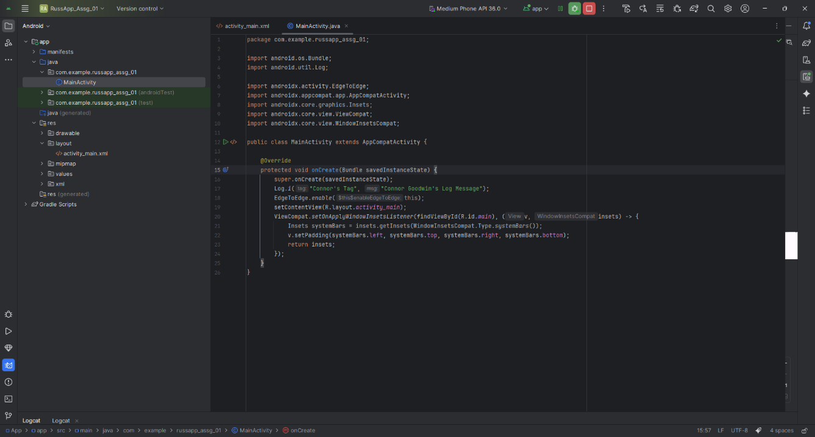
- CODE – Line 17: Shows code that will output to console: “Connor Goodwin’s Log Message” with the tag “Connor’s Tag”.

ANDROID EMULATOR
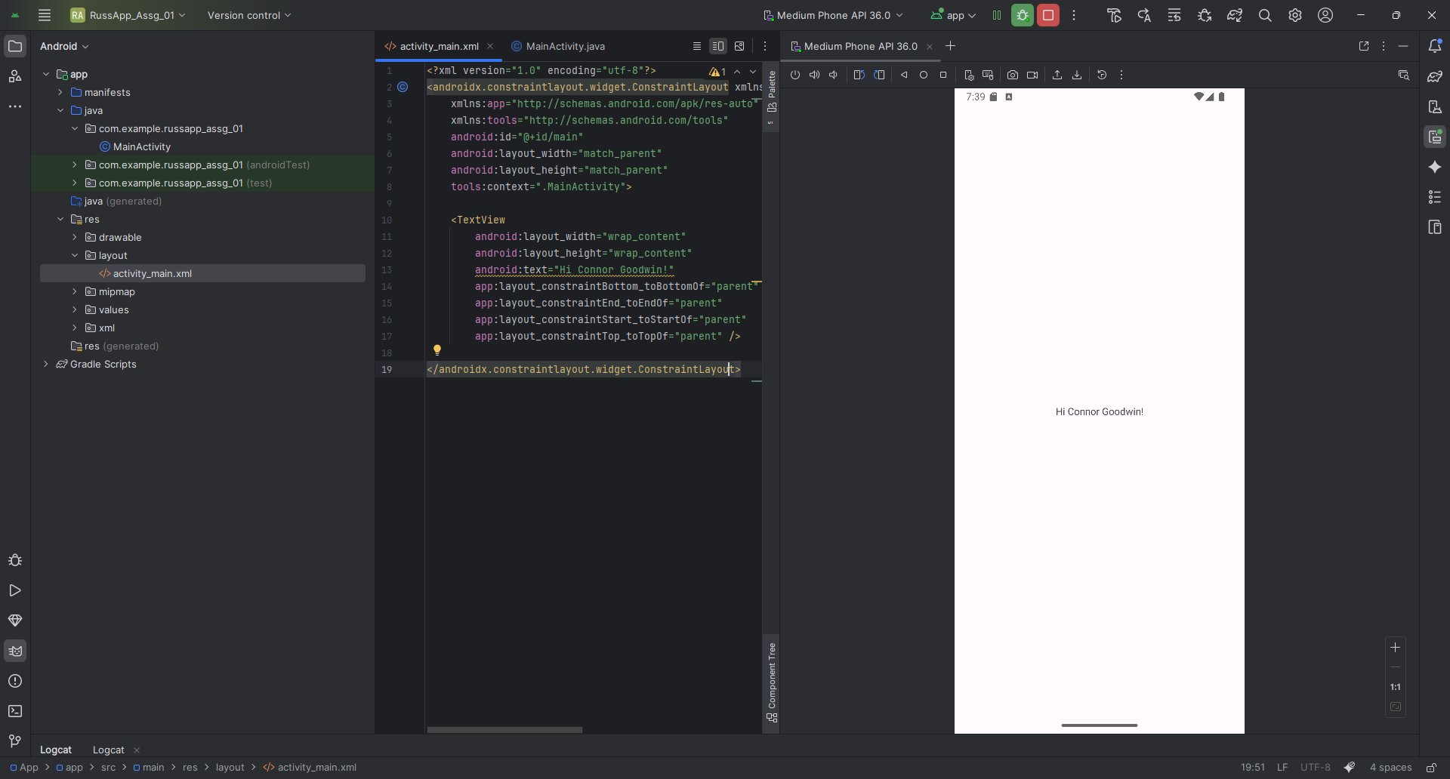
- Android Emulator – Emulator shows the text on the screen that line 13 produces.

CONSOLE OUTPUT
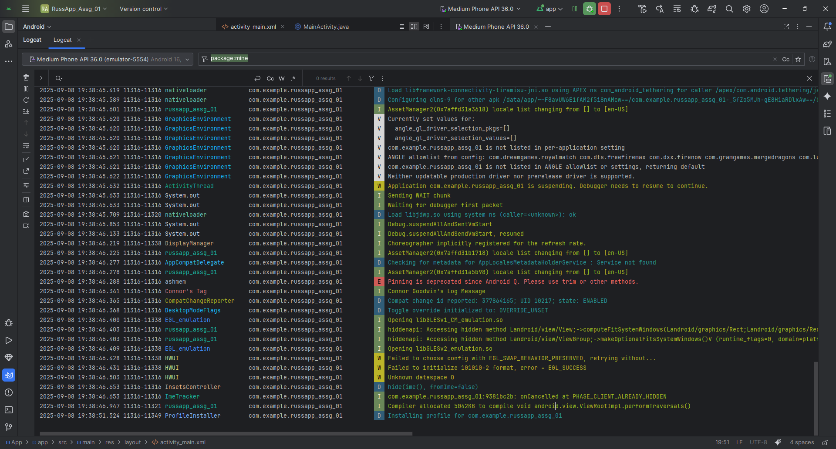
Console Output – Output showing various things, but as shown at time: 2025-09-08 19:38:46.341, shows the tag “Connor’s Tag” in red on the left and “Connor Goodwin’s Log Message” in green on the right.

